Permu-Tater Wireframe
Will Riffe’s Site Prototype

Introduction

The website design proposed in my ideation document is called Permu-Tater— a random recipe generating website. Some of the features include: a form entry screen which allows customization of the recipe you want to generate, a “cook book” section for saving generated recipes.Users can create an account in order to post and save their meal preferences.

User Interface Design and Prototype

The user will be able to navigate between the recipe generator, the cook book, a faq page, and an about page using the site navbar. The accordion will expand to allow the user to use the search bar on xs screens. The user may use the search bar to look for recipes, or forum subjects throughout the site.

The user will be able to sign in and view their account info using the ellipses in the upper right-hand portion of the screen; where they can save their general preferences (including food related preferences for recipe generation or searching).

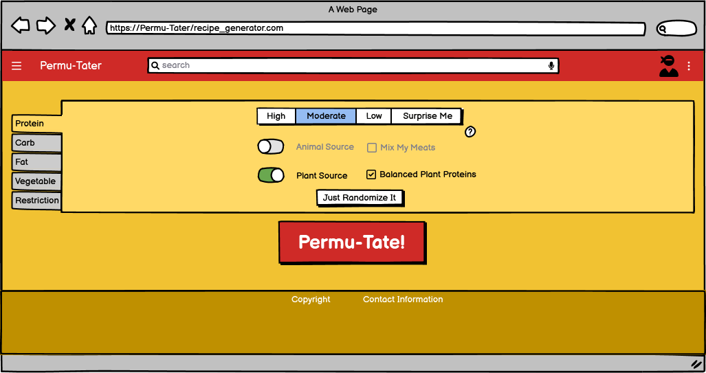
On the “Recipe Generator” page, the user may alter the aspects of recipe regarding macronutrients—such as protein, carbs, fats—and allow the user to exclude certain components in the event the user has a food preference or sensitivity. Each category will also use a “Surprise Me” button which will randomize the preferences under that category. After the user is finished with any inputs, they simply have to hit the “Permu-Tate!” button to generate a recipe.

